**Guesty Plugin Documentation Outline**

1. Introduction

It is plugin which manage reservation and listing in admin side.

Then it makes to facilitate villa bookings with Guesty integration.

1. Installation

* Requirements
* Wordpress: v6.6.1
* Php version that can run this WP.
* Guesty API account and credentials
* Installation Steps
* Downloading the plugin Php version that can run this WP.
* Installing the plugin via the Wordpress Admin Dashboard
* Check
* If it is installed correctly, it would exist in the wp-content/plugins /guesty-integration directory.

1. Setup and Configuration

* Initial Setup
* Activate plugin
* Download and activate font-awesome plugin
* Accessing the plugin settings page
* Guesty integration
* Go to “API Settings” page and have to enter the Guesty API credentials and select the environment.

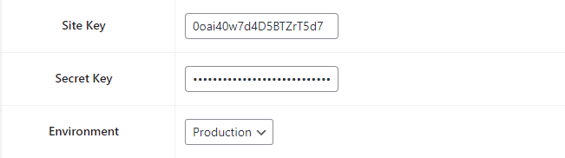

* After verify the integration, it can be allowed accessing the data.

1. Plugin Features

* Villa Listings
* Go to “Listings” feature, and view all listing of villa and apartment.

They have their primary ID that can identify each villa.

And “Name”, “City” are features of existing villas in the system.

* It is possible to find out appropriate villa by name and city.
* List Detail
* When it is needed detail for every list, click that ID and can go to detail page.
* In that page, it is mentioned about detail like location, bedrooms, capacity of guests and bathrooms.  
  And admin can see the description, amenities and gallery.
* Availability
* If admin goes to “availability” page, it
* First, input data for each field of “All Accommodation Type” and period.
* Then it is displayed the statues for each villa and apartment.

There are four statues “Booked”, “Pending”, “External”, “Blocked”.

Calendar shows these statues with various colours.

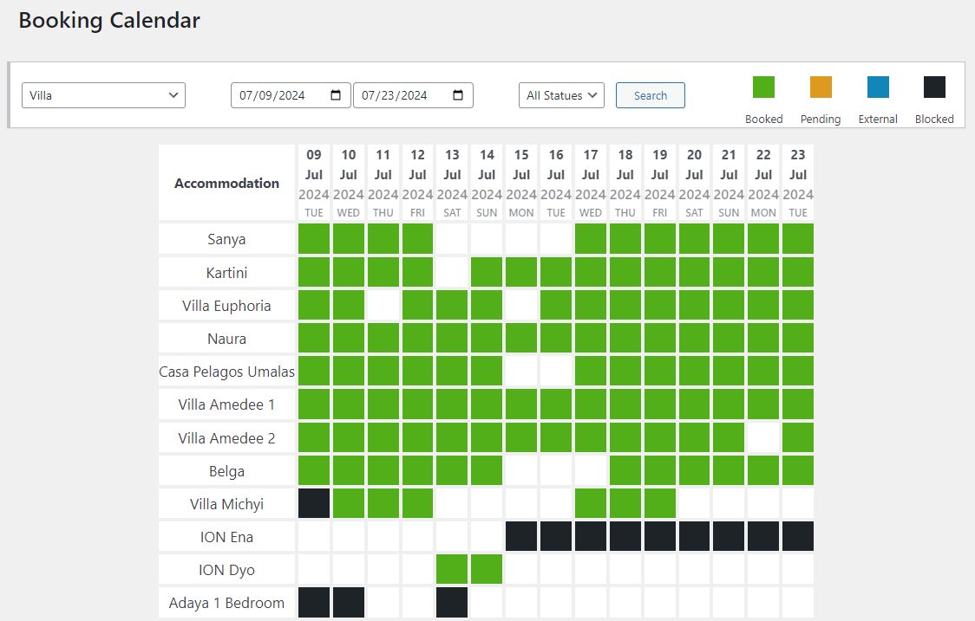

1. Advanced features

* Shortcodes
* First, it is existing “guesty_reservation_quote” shortcode.

This implements forms and functionality for the reservation quote based on search engine.

* If searched lists are displayed, “guesty_booking_quote_form” shortcode generate reservation quote for each villa.

So user can know the quote for their demand.

* And also user can know the detail for the villa that he/she wants.

This is similar page with the “list detail” of plugin.

So this part becomes to shortcode function

* API endpoints
* To display information about villa, the plugin uses API endpoints that service provide.
* In includes directory of plugin Guesty_API class is declared.

This class has base url of guesty and token for accessing which generated from api credential id and key.

So it allows bringing data to all pages.

1. Frontend of theme

* Setup pages
* To display payment and detail page to users, admin has to add new page on the dashboard.
* Go to “Add new page” and to make payment page, admin has to write “payment” in title and click the “Publish” button.

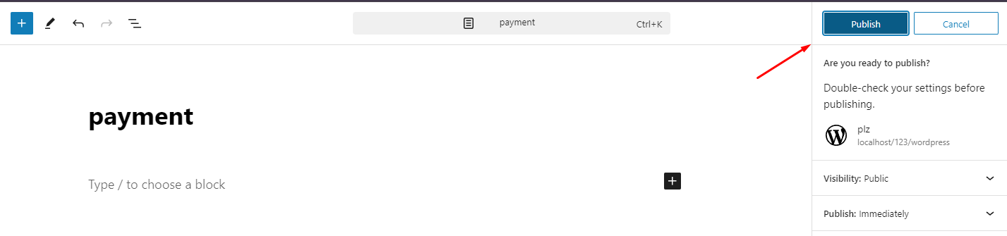

* With same way, admin can create “list-detail” page on the theme.
* And then these pages can interact with “page-payment.php” and “page-list-detail.php”.

**Conclusion**

This documentation outline provides a comprehensive structure for your WordPress plugin's documentation. Each section should include detailed instructions, examples, screenshots, and troubleshooting tips to help users effectively install, configure, and use your plugin.